Module 6

Assignment 6.2
Course: CSD402-340A Java for Programmers
Prepared By: Mirach Erkol
Date of Report: 2/14/2025

https://github.com/Mikey5007/CSD340.git

6.2 Assignment: Build a Webpage Exercise
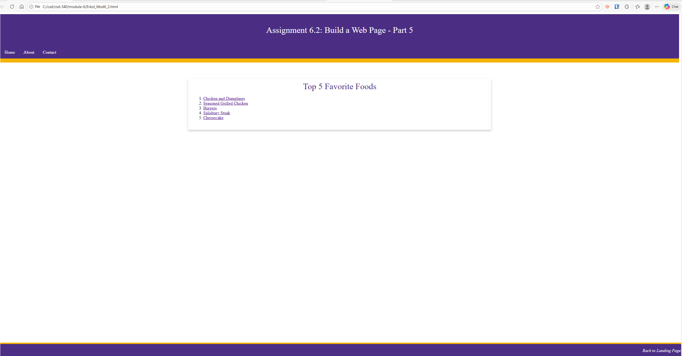
6.2 Assignment: Homepage with Assignment 6.2 Link
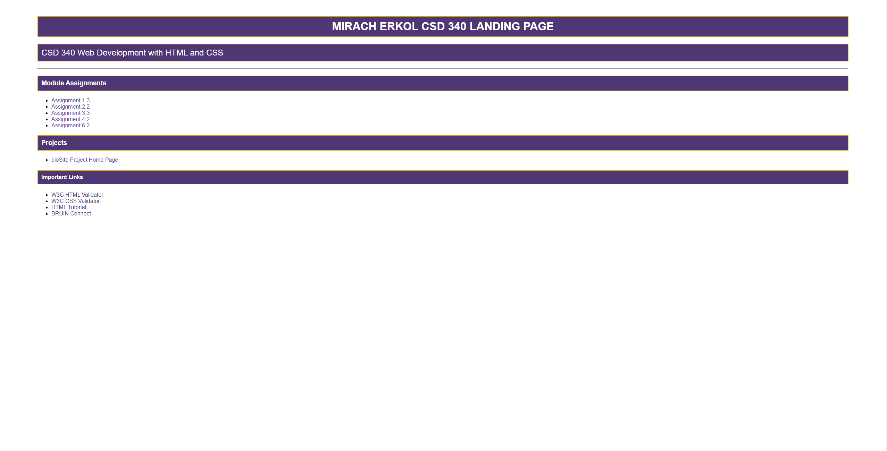
References:

https://github.com/Mikey5007/CSD340.git

